
Entertainment Schedule
October 2018
Stump Trivia Tues 7-9 PM &
Live Music Wed-Sat 7:30-10:30PM
SUNDAY | MONDAY | TUESDAY | WEDNESDAY | THURSDAY | FRIDAY | SATURDAY
 | 1 | 2  Stump Trivia | 3  Joy Reo & Molly Flannery  Sassy & Soulful Jazz Standards, Pop Classics & Broadway Tunes | 4  John Fitzsimmons & Friends- Traditional Pub Music | 5  Bill Mc Goldrick & Danielle Jean Acoustic Duo | 6  John Fitzsimmons & The Salty Dogs  Traditional Pub Music
7 | 8  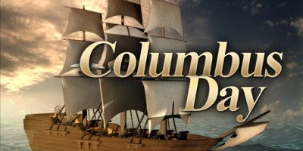 | 9  Stump Trivia | 10  Moshe Feldmen  Piano | 11  John Fitzsimmons & Friends- Traditional Pub Music | 12  Alan Goodrich  Acoustic rock | 13  Colleen Marshall & Eriik Ringstad  Soul Pop Duo
14 | 15 | 16  Stump Trivia | 17  Molly Flannery & The Fernando Holz Band  Brazilian Jazz, Pop, Sambas & Bossa Novas | 18  John Fitzsimmons & Friends- Traditional Pub Music | 19  Rich Berlin & Massmania | 20  Wendee Glick & Friends  Jazz Standards
21 | 22 | 23  Stump Trivia | 24  Aunt Mimi- Acoustic Guitar Pop hits and Rock Edge | 25  John Fitzsimmons & Friends- Traditional Pub Music | 26  Brittany Hill | 27  Rhea Simon  Jazz Standards
28 | 29 | 30  Stump Trivia | 31  Silverlock  Covers & originals in a variety of styles  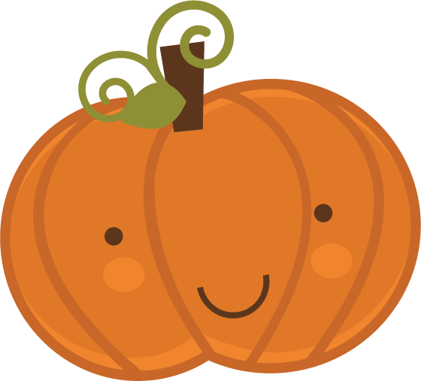
48 Monument Sq, Concord, MA 978-369-2373 www.concordscolonialinn.com

