
Entertainment Schedule
October 2016
Stump Trivia Tues 7-9 PM &
Live Music Wed-Sat 7:30-10:30PM
SUNDAY | MONDAY | TUESDAY | WEDNESDAY | THURSDAY | FRIDAY | SATURDAY
1
John Fitzsimmons & The Salty Dogs
Traditional Pub Music
2 | 3 | 4  Stump Trivia | 5  Joy Reo & Molly Flannery  Sassy & Soulful Jazz Standards, Pop Classics & Broadway Tunes | 6  John Fitzsimmons & Friends- Traditional Pub Music | 7  Bill Mc Goldrick & Danielle Jean Acoustic Duo | 8  Colleen Marshall & Eriik Ringstad  Soul Pop Duo
9 | 10 | 11  Stump Trivia | 12  Aunt Mimi- Acoustic Guitar Pop hits and Rock Edge | 13  John Fitzsimmons & Friends- Traditional Pub Music | 14  Alan Goodrich  Acoustic rock | 15  Wendee Glick & Friends  Jazz Standards
16 | 17 | 18  Stump Trivia | 19  Molly Flannery & The Fernando Holz Band  Brazilian Jazz, Pop, Sambas & Bossa Novas | 20  John Fitzsimmons & Friends- Traditional Pub Music | 21  Rich Berlin & Massmania | 22  Kenny Selcer
23  30 | 24  31  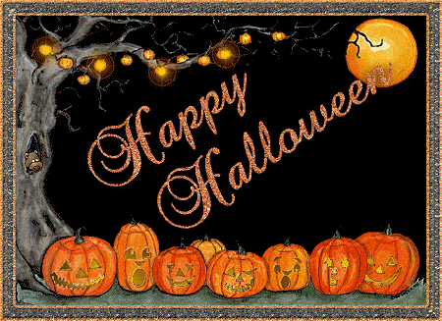 | 25  Stump Trivia | 26  Silverlock  Covers & originals in a variety of styles | 27  John Fitzsimmons & Friends- Traditional Pub Music | 28  Brittany Hill | 29  Rhea Simon  Jazz Standards
48 Monument Sq, Concord, MA 978-369-2373 www.concordscolonialinn.com

