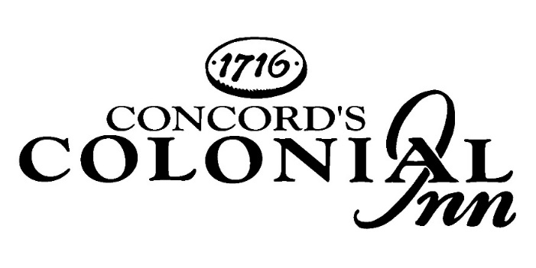

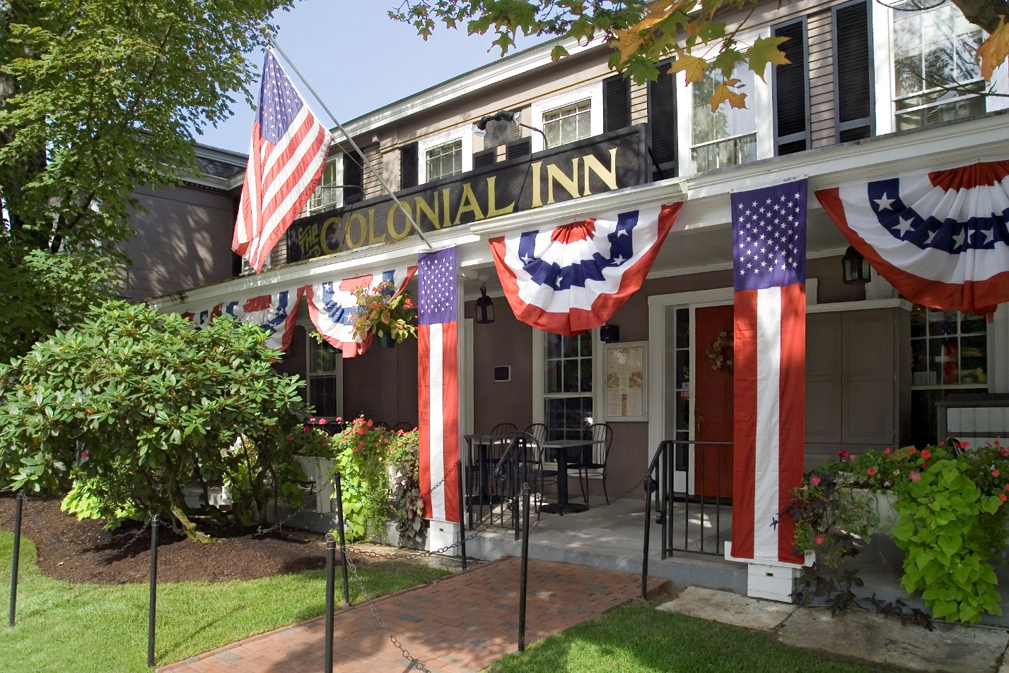
The
Catering Menu

Meeting Packages
Just add the lunch of your choice to one of these packages for a full day affair.

Standard Meeting Package $15.00

Continental Breakfast
Fresh Bakery Selections, Bagels,
Cream Cheese, Fruit Preserves
Seasonal Fresh Fruit
Chilled Fruit Juices
Coffee & Tea Service

Mid-Morning Refresh
Freshly Brewed Coffee,
Decaffeinated Coffee and Tea

PM Pick-Me-Up
Assortment of Cookies
and Sliced Fresh Fruit
Coffee, Decaffeinated Coffee and Tea

Executive Meeting Package $25.00

Classic Breakfast
Seasonal Fresh Fruit
Fresh Bakery Selections, Bagels,
Cream Cheese, Fruit Preserves
Scrambled Eggs
Bacon & Maple Sausage
Colonial Inn Home Fries
Chilled Fruit Juices
Coffee & Tea Service

Mid-Morning Refresh
Freshly Brewed Coffee,
Decaffeinated Coffee and Tea

PM Pick-Me-Up
Assortment of Cookies, Brownies,
and Sliced Fresh Fruit
Coffee, Decaffeinated Coffee and Tea

Breakfast Buffets

Continental $13.00
Seasonal Fresh Fruit
Fresh Bakery Selections, Bagels, Cream Cheese, Fruit Preserves
Chilled Fruit Juices
Coffee & Tea Service
Fresh Start $15.00
Granola
Greek Yogurt
Fresh Fruit Salad
Chilled Fruit Juices
Coffee & Tea Service
The Classic $23.00
Seasonal Fresh Fruit
Fresh Bakery Selections, Bagels, Cream Cheese, Fruit Preserves
Scrambled Eggs
Bacon & Maple Sausage
Colonial Inn Home Fries
Chilled Fruit Juices
Coffee & Tea Service

The Healthy Start $23.00
Seasonal Fresh Fruit
Assorted Cereals, Skim Milk
Greek Yogurt & Granola Parfait
Cottage Cheese
Egg White Frittata, Bell Peppers, Onions, Tomatoes and Cheese
Chilled Fruit Juices
Coffee & Tea Service

The Elaborate Brunch Buffet $32.00
(Minimum of 20 Guests)

Seasonal Fresh Fruit and Granola
Fresh Bakery Selections, Bagels, Cream Cheese, Fruit Preserves
Scrambled Eggs
Bacon & Maple Sausage
Colonial Inn Home Fries
Quiche Florentine, Spinach, Tomatoes, Cheese
Choice of Fish Entrée: Fresh Salmon or Ritz Cracker Crusted Cod with Citrus Beurre Blanc
Choice of Chicken Entrée: Florentine, Piccata or Marsala Sauce
Two Seasonal Salads
Fresh Baked Cornbread & Sourdough Rolls
Assorted Pastries
Chilled Fruit Juices
Coffee & Tea Service

Breakfast Plated DELETING THIS

Country Morning Breakfast $18.00
(Select One)
Scrambled Eggs
Pancakes, Fresh Berries, Maple Pecan Butter
Challah French Toast, Bananas Foster Compote
(Select One)
Bacon
Maple Sausage
Ham
Colonial Inn Breakfast Potatoes
Chilled Fruit Juices

Breakfast & Brunch Enhancements

Assorted Cold Cereals, Milk $4.00
Individual Assorted Yogurts $4.00
Bagels, Cream Cheese, Fruit Preserves $4.00
Colonial Inn Home Fries $4.00
Bacon $4.00
Maple Sausage $4.00
Ham Steak $5.00
Corned Beef Hash $5.00
Seasonal Fruit Salad $5.00
Assorted Breakfast Pastries $5.00
Smoked Salmon $7.00
Lunch Buffets
(Minimum of 15 Guests)
The New England Deli $24.00
Chef’s House Made Soup of the Day
Tossed Garden Greens, Tomato, Cucumber, Red Wine Vinaigrette
Pasta Salad, Olives, Red Onion, Feta Cheese, Roasted Red Pepper, Lemon Vinaigrette
Roast Beef, Roast Turkey Breast, Sliced Baked Ham
Swiss, Cheddar, American Cheese
Lettuce, Sliced Tomato, Red Onions, Pickles
Country White, Wheat, Brioche Rolls, Wraps
Traditional Mustard, Grainy Mustard, Horseradish Cream, Mayonnaise
Potato Chips
Chef’s Choice of Dessert

Light Salad Luncheon $25.00
Chef’s House Made Soup of the Day
Select Two
Caesar Salad, Parmesan Cheese, Garlic Croutons
Mixed Greens Salad, Tomato, Cucumber, Carrots, Red Wine Vinaigrette
Cobb Salad, Romaine, avocado, bacon, blue cheese, egg, corn, tomato, ranch dressing
Waldorf Salad, Field greens, apple, walnuts, celery, cranberry cheese, grapes, tarragon dressing
Select Two
Tuna Salad, Chicken Salad, Egg Salad, Mediterranean Pasta Salad, Red Bliss Potato Salad

Grilled Chicken
Country White, Wheat, Brioche Rolls
Lettuce, Sliced Tomato, Red Onion
Potato Chips
Chef’s Choice of Dessert
Upgrade to New England Clam Chowder $2.00
Add Grilled Shrimp, Salmon or Steak $5.00
The Executive Deli $26.00
Chef’s House Made Soup of the Day
Tossed Garden Greens, Tomato, Cucumber, Red Wine Vinaigrette
Pasta Salad, Olives, Red Onion, Feta Cheese, Roasted Red Pepper, Lemon Vinaigrette
Select Three Pre-Made Sandwiches:
Turkey Club
Grilled Chicken Caesar Wrap
Baked Ham & Swiss with Dijonaisse on Sourdough
Mediterranean Wrap - Roasted Vegetables with Feta Cheese in a Whole Grain Wrap
Potato Chips
Chef’s Choice of Dessert
Coffee, Decaffeinated Coffee, Tea

Lunch Hot Buffet $34.00
(Minimum of 20 Guests)

Salad
(Select One)
Caesar Salad, Parmesan Cheese, Croutons
Mixed Green Salad, Shaved Local Vegetables, Maple Vinaigrette
Chopped Romaine, Cherry Tomato, Red Onions, Ranch Dressing

Entrées
(Select Two)
Chicken Cordon Bleu, Mushroom Demi Glaze
Chicken Piccata, Capers, Lemon, Tomato Butter Sauce
Tuscan Grilled Chicken, Olives, Capers, Artichokes, Tomatoes
Ritz Cracker Crusted Cod, Citrus Beurre Blanc
Seared Salmon, Fennel Orange Slaw, Pomegranate Reduction
Yankee Pot Roast, Roasted Carrots, Cippolini Onions
Chipotle Brown Sugar Crusted Pork Loin, Apple Demi
Marinated Brandt Bistro Steak, Caramelized Onions and Peppers
Pasta Primavera, Fresh Vegetables, Penne, Parmesan Cheese, Lemon Butter
Spinach and Cheese Ravioli, House Marinara, Shaved Parmesan Cheese
Quinoa Pilaf, avocado, Rainbow kale, Grilled asparagus, Roasted carrots, cranberry cheese

Sides
(Select Two)
Mashed Potato
Roasted Garlic Herb Potato
Rice Pilaf
Pesto Couscous
Vegetable Medley with Lemon Butter
Green Beans, Caramelized Onions
Roasted Carrots Glazed, Local Honey, Herbs

Dessert
(Select One)
Orange Pound Cake, Fresh Strawberries, Whipped Cream
Seasonal Bread Pudding
Cheesecake with Strawberry Sauce
Chocolate Cake

Coffee, Decaffeinated Coffee, Tea

Plated Lunch
All plated meals served with assorted fresh baked cornbread and rolls

Appetizer
(Select One)
Chef’s Seasonal Soup
New England Clam Chowder
Minestrone
Spinach Salad, Fresh Buffalo Mozzarella, Tomatoes, Red Onions, Bacon Vinaigrette
Mixed Green Salad, Shaved Local Vegetables, Maple Vinaigrette
Caesar Salad, Parmesan Cheese, Croutons, Creamy Caesar Dressing

Entrée
(Select Two)
Quinoa Medley $23.00
Quinoa pilaf, avocado, Rainbow kale, Grilled asparagus, Roasted carrots, cranberry Wensleydale cheese, crispy carrot curl
Chicken Pot Pie $25.00
Our Classic Recipe, Puff Pastry, Mashed Potatoes, Green Beans

Statler Chicken Breast Chicken Marsala? $27.00
Tuscan Tomato Sauce, Roasted Herbed Potatoes, Green Beans

Grilled Bistro Steak $29.00
Roasted Potatoes, Green Beans, Mushroom and Rosemary Au Jus

Baked Cod $33.00
Ritz Cracker Crumbs, Mashed Potatoes, Green Beans, Citrus Beurre Blanc

Broiled Salmon $33.00
Fennel Slaw, Pomegranate Reduction, Mashed Potatoes, Green Beans

Dessert
(Choose One)
Maine Blueberry & Lemon Challah Bread Pudding, White Chocolate Anglaise
Molten Chocolate Stout Cake, Dark Chocolate Ganache, Whipped Cream
Orange Pound Cake, Fresh Strawberries, Whipped Cream
Raspberry Crème Brûlée

Coffee, Decaffeinated Coffee, Tea

Plated Dinners
All plated meals served with assorted fresh baked cornbread and rolls

Appetizer
(Select One)
Chef’s Seasonal Soup
New England Clam Chowder
Minestrone
Caesar Salad, Hearts of Romaine, Parmesan Cheese, Croutons, Creamy Caesar Dressing
Mixed Greens Salad, Cherry Tomatoes, English Cucumbers, Dijon Vinaigrette
Steak House Wedge, Bacon, Bleu Cheese, Pickled Onion, Tomato
Tomato & Mozzarella, Balsamic Vinaigrette, Micro Greens

Intermezzo $3.00
(Select One)
Lemon Sorbet
Raspberry Sorbet
Mango Sorbet

Entrée
(Select Two)

Vegetarian
Penne Primavera $30.00
Fresh Local Vegetables, Tomato Broth, Parmesan Cheese
Quinoa Medley $32.00
Quinoa pilaf, avocado, Rainbow kale, Grilled asparagus, Roasted carrots, cranberry Wensleydale cheese, crispy carrot curl
Spinach and Cheese Ravioli $33.00
Marinara Sauce, Shaved Parmesan Cheese
Truffle Risotto with Asparagus and Tomato $34.00
Drizzled Basil Oil

Poultry
Moroccan Chicken $35.00
Saffron and Lemon Couscous, Asparagus, Almond Apricot Chutney
Chicken Cordon Bleu $35.00
Mushroom Demi Glaze, Mashed Potatoes, Braised Spinach
Statler Chicken Breast $36.00
Herbed Roasted Potatoes, Green Beans, Rosemary Au Jus

(continued on next page)
Seafood
Seared Salmon $36.00
Pomegranate Reduction, Orange Fennel Salad, Cranberry Risotto
Ritz Cracker Crusted Boston Cod $37.00
Mashed Potatoes, Braised Spinach, Citrus Beurre Blanc
Grilled Center-Cut Swordfish $38.00
Artichoke Tomato Ragout, Herbed Roasted Potatoes, Red Pepper Coulis

Beef & Pork
10oz. Grilled Pork Chop $41.00
Herbed Roasted Potatoes, Honey Glazed Carrots, Maple Cider Glaze
10oz. New York Sirloin $46.00
Buttermilk Mashed Potato, Lemony Grilled Asparagus, Bordelaise
8oz. Filet Mignon $48.00
Buttermilk Mashed Potatoes, Braised Spinach, Mushroom Demi- Glaze

Surf & Turf
Petit Steak & Shrimp $53.00
Herbed Roasted Potatoes, Braised Spinach, Sauce Au Poivre
Petit Steak & Sea Scallops $60.00
Herbed Butter, Demi-Glace
Petit Pork Tenderloin & Crab Stuffed Shrimp $52.00
Béarnaise Sauce

Dessert
(Select One)
Blueberry Bread Pudding, White Chocolate Anglaise
Double Chocolate Mousse
Lemon Meringue Tart, Raspberry Sauce
Orange Pound Cake, Fresh Strawberries, Whipped Cream

Coffee, Decaffeinated Coffee, Tea

Dinner Buffets

The New England Buffet $40.00
(Minimum of 20 Guests)

Soup
New England Clam Chowder

Salad
(Select One)
Boston Bibb, New Hampshire Bacon, Tomato, Onion, Balsamic Vinaigrette, Goat Cheese, Herbs
Local Mixed Greens, Great Hill Bleu Cheese Dried Cranberries, Walnuts, Champagne Vinaigrette
Traditional Caesar Salad, Crispy Crouton, Shaved Parmesan Cheese

Entrées
New England Baked Chicken, Rosemary and Lemon Pepper Gravy
Boston Ritz Cracker Crusted Cod, Citrus Beurre-Blanc
Grilled Marinated Bistro Steak, Mushroom Bordelaise

Add 1 Pound Lobster Market Price

Starch and Vegetable
Herbed Roasted Potatoes
Roasted Vegetable Medley or Steamed Green Beans
Rolls & Cornbread

Dessert
(Select One)
Apple Pie
Boston Crème Pie
Indian Pudding, Vanilla Ice Cream

The Colonial Buffet $45.00
(Minimum of 20 Guests)

Salad
(Select Two)
Chef’s Seasonal Soup
New England Clam Chowder
Minestrone
Mixed Greens, Bacon, Red Onions, Cherry Tomato, Lemon Vinaigrette
Baby Spinach, Fresh Buffalo Mozzarella, Red Onions, Diced Tomatoes, Bacon Vinaigrette
Traditional Caesar Salad, Crispy Crotons and Shaved Parmesan Cheese

Entrées
(Select Two)
Chicken Cordon Bleu, Mushroom Demi Glaze
Chicken Piccata, Capers, Lemon, Tomato Butter Sauce
Grilled Chicken Marsala, Prosciutto and Mushroom Demi Glaze
Ritz Cracker Crusted Cod, Citrus Beurre Blanc
Seared Salmon, Fennel Orange Slaw, Pomegranate Reduction
Grilled Swordfish, Artichoke and Tomato Ragout
Yankee Pot Roast, Roasted Carrots, Cippolini Onions
Chipotle Brown Sugar Crusted Pork Loin, Roasted Apple Thyme Demi
Marinated Brandt Bistro, Caramelized Onions and Peppers
Spinach and Cheese Ravioli, House Marinara, Shaved Parmesan Cheese
Quinoa Pilaf, avocado, Rainbow kale, Grilled asparagus, Roasted carrots, cranberry cheese

Sides
(Select Two)
Mashed Potato
Roasted Garlic Herb Potato
Rice Pilaf
Pesto Couscous
Vegetable
Vegetable Medley with Lemon Butter
Green Beans, Caramelized Onions
Roasted Carrots Glazed

Dessert
(Select One)
Bread Pudding, Rum Anglaise
Chocolate Mousse
Lemon Meringue Tart
Passed Hors d’ Oeuvres

Cold
Bruschetta, Tomato, Basil, Parmesan, EVOO, Saba* $3.00
Black Olive Tapenade Crostini, Parmesan Cheese, Basil Oil* $3.00
Fresh Mozzarella, Tomato, Basil Skewer, EVOO, Balsamic Glaze* $3.00
Asparagus Wrapped with Prosciutto, Sweet Balsamic Drizzled $4.00
Ahi Tuna Wontons, Seaweed Salad, Pickle Ginger, Sesame Soy Sauce $4.00
Shrimp Cocktail, Horseradish Cocktail Sauce, Lemon $4.00
Mediterranean Chicken Bites, tzaziki, tomato, feta
Chicken Salad cups
Smoked Salmon Canapés, Crostini, chive cream cheese, capers $5.00
Crab Salad Brioche, Lemon Tarragon Vinaigrette $5.00
Herb Crusted Beef Tenderloin, Crouton, Horseradish Crème, Pickled Red Onion $5.00
Lobster Salad Crostini, Lemon Aioli $6.00

Hot
Goat Cheese & Leek Stuffed Mushroom* $3.00
Spanikopita Or Spinach Cheese bites* $3.00
Artichoke Beignet, Tomato Aioli* $3.00
Vegetable Spring Roll, Soy Orange Dipping Sauce* $3.00
Chicken Santa Fe Purse, Tomato Salsa $3.00
Chicken Cordon Bleu Minis
Gyoza Pork Potsticker, Ginger Soy Dipping Sauce $3.00
Buffalo Chicken Fried Ravioli Blue Cheese Dressing $3.00
Scandinavian Meat Balls $4.00
Coconut Shrimp, Sweet Chili Dipping Sauce $4.00
Petit Crab Cakes, Old Bay Tartar Sauce $4.00
Mini Beef Wellington, Creamy Horseradish Sauce $4.00
Bacon Wrapped Scallops *Please price on the larger ones $5.00

* Vegetarian Option

Can be served butler-passed or stationary
Platters server 25 pieces

Hors d’oeuvres Packages
Collection I - choice of two *stationary and two passed hors d’oeuvres $12.50
Collection II - choice of two *stationary and three passed hors d’oeuvres $14.50
Collection III - choice of three *stationary and five passed hors d’oeuvres $17.50
*Upgrade to Enhanced Stationary * $ ____
Stationary Hors d’ Oeuvres
Each platter serves 15-20 guests

Baked Brie en Croûte $75.00
Seasonal Fruit, Baguettes

Vegetable Crudité Platter $90.00
Assortment of Chilled Vegetables (Broccoli, Cauliflower, Celery, Carrots,
Cherry Tomatoes, Cucumbers) Herb Ranch & Blue Cheese Dipping Sauces

Fresh Fruit $100.00
Honeydew, Cantaloupe, Pineapple, Oranges, Grapes,
Seasonal Berries, Yogurt Dipping Sauce

Domestic Cheese Platter $130.00
Cheddar, Brie, Pepper Jack, Goat Cheese, Dill Havarti, Bleu
Seasonal Berries, Grapes, Crackers

Charcuterie Board
Cheeses, meats, mustards, fruits

Spanish Tapas $140.00
Olive Medley, Nuts, Fresh Salsa, Guacamole, Hummus, Pita Chips,
Marinated Roasted Eggplant & Roasted Peppers

Antipasto $150.00
Salami, Prosciutto
Marinated Mushrooms & Artichokes, Roasted Peppers, Olives, Tomato Bruschetta
Crostini, Grilled Vegetables, Marinated Fresh Buffalo Mozzarella

Shrimp Cocktail
Cocktail sauce, lemons, horseradish

Raw Bar Display $15.00
Shrimp, Oysters, Clams, Salmon Tartar
Cocktail Sauce, Mignonette, Wakame

Beverage Options

NON-ALCOHOLIC BEVERAGES

Soda $3.00 each
Bottled Water Small 12oz $3.00 each
Large 28oz $6.00 each
Pitcher of Iced Tea or Lemonade $12.00 each
(Serves 6 people)
Coffee, Tea, or Decaffeinated Coffee $4.00 per person

SPECIALTY PUNCHES

Fruit Punch (Non-Alcoholic) $35.00
Hot Mulled Cider (Non-Alcoholic) $35.00
Egg Nog (Non-Alcoholic) $35.00
Rum Spiked Egg Nog $75.00
Mimosa $75.00
Bloody Mary $75.00
Sangria (White or Red) $90.00
Kir Royal $90.00

Punches are priced per gallon and each gallon serves approximately 18-20 glasses

ALCOHOLIC BEVERAGES

Bottled Beer $5.00-$6.00
Wine (glass) $8.00-$13.00
Cordials $8.00-$12.00
Mixed Drinks $9.00-$11.00
Martinis $11.00-$13.00
General Information

Menu Selection
Please submit a final menu selection no later than two (2) weeks prior to event date to the Catering office. All food items must be supplied and prepared by Concord’s Colonial Inn. Any food prepared by Concord’s Colonial Inn may not be taken off the premises due to insurance and health code regulations.

Beverage
The sale and service of all alcohol is strictly regulated by the Massachusetts Alcohol Beverage Commission. As a licensee, Concord’s Colonial Inn is responsible for the administration of these regulations. Our policy is that all alcoholic beverages must be supplied by Concord’s Colonial Inn. The Hotel reserves the right to limit and control the amount of alcoholic beverages consumed by hotel guests. No alcoholic beverages are allowed to leave Concord’s Colonial Inn. The duration of service for alcoholic beverages is limited to no more than five (5) hours per event.

Guarantees
A guarantee of the exact number of guests for all functions is required seven (7) days prior to the function; otherwise, the highest estimated number will be used as a guarantee. In addition, events offering multiple entrees will need to submit exact numbers of each. Final guarantee is not subject to reduction.

Prices
All prices are subject to change without notice.

Service Charge
An 18% service charge, which is distributed in its entirety to wait staff and bartenders, will be added to all food and beverage items.

State and Local Taxes
All prices are subject to 7% Massachusetts State Sales Tax and Local Meals Tax.

Administrative Fee
A 4% administrative fee is retained by the hotel to defer overhead costs and therefore no portion of this administrative fee is distributed to hourly paid service staff. This fee is taxable at 7%.

Deposits
A non-refundable, non-transferable deposit will be due at the time of booking.

Payments
All functions must be paid in full five (5) business days prior to the event. Payment must be made in the form of cash, certified check or credit card. A credit card must be provided to cover any additional charges that may be added during your event.

Rooms
The hotel reserves the right to charge a service fee for set up of function rooms. If additional setup time is required, this must be contracted at time of booking. Guest will not have access to rooms until event begins. Minimum requirements and room charges exist at certain times of the year. Please inquire with our Sales Department for specifics.

Conduct of Event
In compliance with applicable laws, regulations and house rules, client assumes full responsibility for the conduct of all persons or vendors in attendance and for any damage done to any part of the hotel’s premises.

Displays and Decorations
All displays and/or decorations proposed by guests must be preapproved in each specific instance. The hotel will not permit the affixing of anything to walls, doors, light fixtures or ceilings of any rooms with materials other than those supplied by Concord’s Colonial Inn. If additional setup time is required, this must be contracted at time of booking. Guests will not have access to room until event begins. Concord’s Colonial Inn will not be responsible for any articles left after the event.

Planning Your Event

Arranging and Reserving a Date
All Colonial Inn Private Events must be booked through the Inn’s Sales and Catering Office. The Sales Staff at the Inn can be reached by phone or email at the following:

Senior Catering Sales Manager Shannon Sinnott
(978)-371-2908, ext. 544 ssinnott@concordscolonialinn.com

Sales Coordinator Chynna Herman
(978)-371-2908, ext.501 cherman@concordscolonialinn.com

For Initial Inquiry through the Booking Process
You will be working with a Sales Manager who will guide you through the entire process and answer any and all questions you may have relevant to the event being planned. Once you have been given all the information necessary, your manager will ask to move forward with a Catering Agreement. This Agreement will outline financial requirements including, but not limited to a Food & Beverage Minimum, an applicable Function Room Rental Fee, and any other charge that would be incurred prior to creating a Banquet Event Order. Once a Catering Agreement has been issued, the client will have up to TWO [2] Weeks from the date of issue to sign the agreement and send it back to the sales manager. At the time of signature, it is the responsibility of the client to indicate a method of payment. Upon review from the sales department, your event will be marked definite in the Inns Catering Diaries, and your initial deposit will then be recorded. Please note: It is the client’s responsibility to read and review all information in the agreement for accuracy and completeness. Please contact your sales manager with any and all questions prior to your written approval and deposit.

Service Upgrades
Concord’s Colonial Inn provides high quality linen, glass, silver and china, however, should your event require a certain look that we are unable to provide, we have the ability to outsource specialty linens, specialty china, flatware and glass. Please ask your Sales Manager for current pricing options.

Linen
Concord’s Colonial Inn provides complimentary standard Damask linen and/or skirting for all food, beverage and dining tables for all special events.

Below are the colors and the associated color schemes that work well with each:
Thoreau Room White, Ivory, Burgundy, Gold, Hunter Green, Pink
Alcott Room White, Ivory, Burgundy, Gold, Hunter Green, Navy Blue
Middlesex Room White, Ivory, Burgundy
Prescott Room White, Ivory, Burgundy, Gold, Navy Blue, Pink
Café White, Ivory, Burgundy

White chair covers are available for rent at an additional charge of $2.00 per chair (max of 85).

Custom Menu Requests and Tastings
If there is something that isn’t incorporated into our menus, but would like to have it on your menu, please consult your catering manager. Every effort will be made to accommodate your requests.

Tastings for Weddings are held in Merchants Row on an individual basis, but only upon execution of a signed Catering Agreement and Deposit.

Special Dietary Requests
Should guests attending a function have any special dietary requests or food allergies and require special meal requirements, the Inn must be notified at least 72 hours in advance with names of guest and catering needs, and the hotel will make the necessary arrangements to accommodate the requests.

The Inn’s kitchens utilizes many different ingredients in menu items and there may be products that contain nuts, nut products, dairy and/or soy products and the like, prepared in these kitchens. The hotel will not be liable for the guests' allergic reactions resulting from partaking in the food items served at any food and beverage outlet and/or function held at Concord’s Colonial Inn. It is therefore the responsibility of the host or hostess to inform the sales manager or catering coordinator of such allergies and the kitchen will do the best they can to accommodate requests.

We are delighted that you have chosen Concord’s Colonial Inn as host to your special event.

With Concord's Colonial Inn, every special event becomes a part of history.
Breakfast

