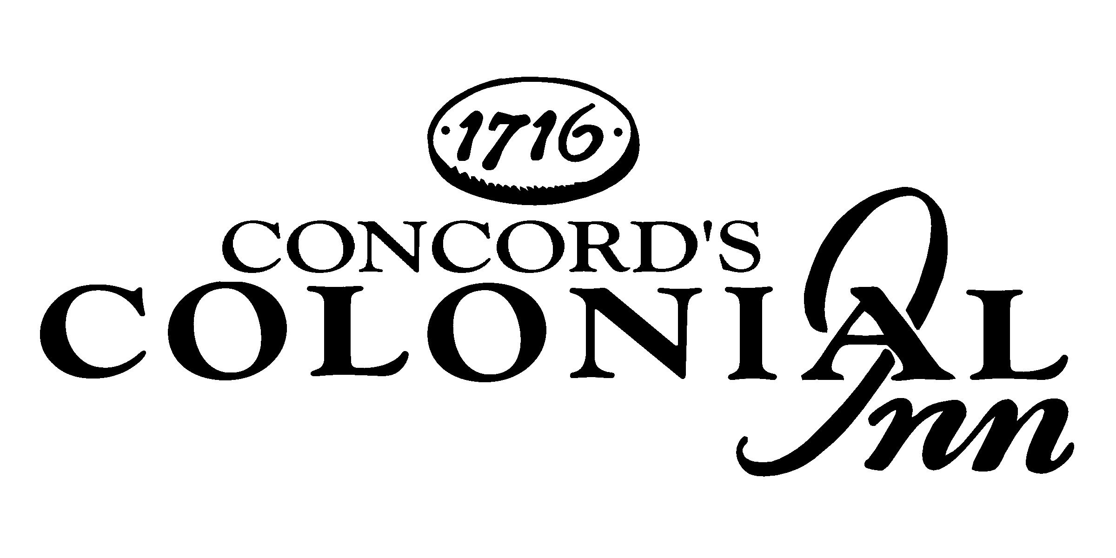

Entertainment Schedule
March 2016
Stump Trivia Tuesdays 7-9 PM
Live Music Wednesday-Saturday 7:30-10:30 PM
Village Forge Tavern

SUNDAY | MONDAY | TUESDAY | WEDNESDAY | THURSDAY | FRIDAY | SATURDAY
 |  | 1 | 2 | 3 | 4 | 5
 |  | Stump Trivia | Joy Reo & Molly Flannery | John Fitzsimmons & Friends Traditional Pub Music | Bill Mc Goldrick & Danielle Jean Acoustic Duo | John Fitzsimmons & The Salty Dogs Traditional Pub Music
6 | 7 | 8 | 9 | 10 | 11 | 12
 |  | Stump Trivia | Moshe Feldmen Piano | John Fitzsimmons & Friends- Traditional Pub Music | Alan Goodrich Acoustic Rock | Colleen Marshall & Eriik Ringstad Soul Pop Duo
13 | 14 | 15 | 16 |   17 | 18 | 19
 |  | Stump Trivia | Molly Flannery | John Fitzsimmons & Friends- Traditional Pub Music | Rich Berlin & Massmania | Rhea Simon Jazz Standards
20 | 21 | 22 | 23 | 24 | 25 | 26
 |  | Stump Trivia | Silverlock Covers & originals in a variety of styles | John Fitzsimmons & Friends- Traditional Pub Music | Brittany Hill | Jennifer Truesdale
27 | 28 | 29 | 30 | 31
 |  | Stump Trivia | Aunt Mimi- Acoustic Guitar Pop hits and Rock Edge | John Fitzsimmons & Friends- Traditional Pub Music

48 Monument Square, Concord, MA · 978-3692373 · www.concordscolonialinn.com

