
Entertainment Schedule
December 2015
Stump Trivia Tues 7-9 PM &
Live Music Wed-Sat 7:30-10:30PM
SUNDAY | MONDAY | TUESDAY | WEDNESDAY | THURSDAY | FRIDAY | SATURDAY
 |  | 1  Stump Trivia | 2  Joy Reo & Molly Flannery | 3  John Fitzsimmons & Friends- Traditional Pub Music | 4  Bill Mc Goldrick & Danielle Jean | 5  Colleen Marshall & Eriik Ringstad  Soul Pop Duo
6   | 7 | 8  Stump Trivia | 9  Moshe Feldmen  Piano | 10  John Fitzsimmons & Friends- Traditional Pub Music | 11  Alan Goodrich | 12  Wendee Glick & Friends  Jazz Standards
13 | 14 | 15  Stump Trivia | 16  Molly Flannery & Guest  Holiday Show | 17  John Fitzsimmons & Friends- Traditional Pub Music | 18  Rich Berlin & Massmania | 19  Rhea Simon  Jazz
20 | 21 | 22  Stump Trivia | 23  Silverlock  Covers & originals in a variety of styles | 24  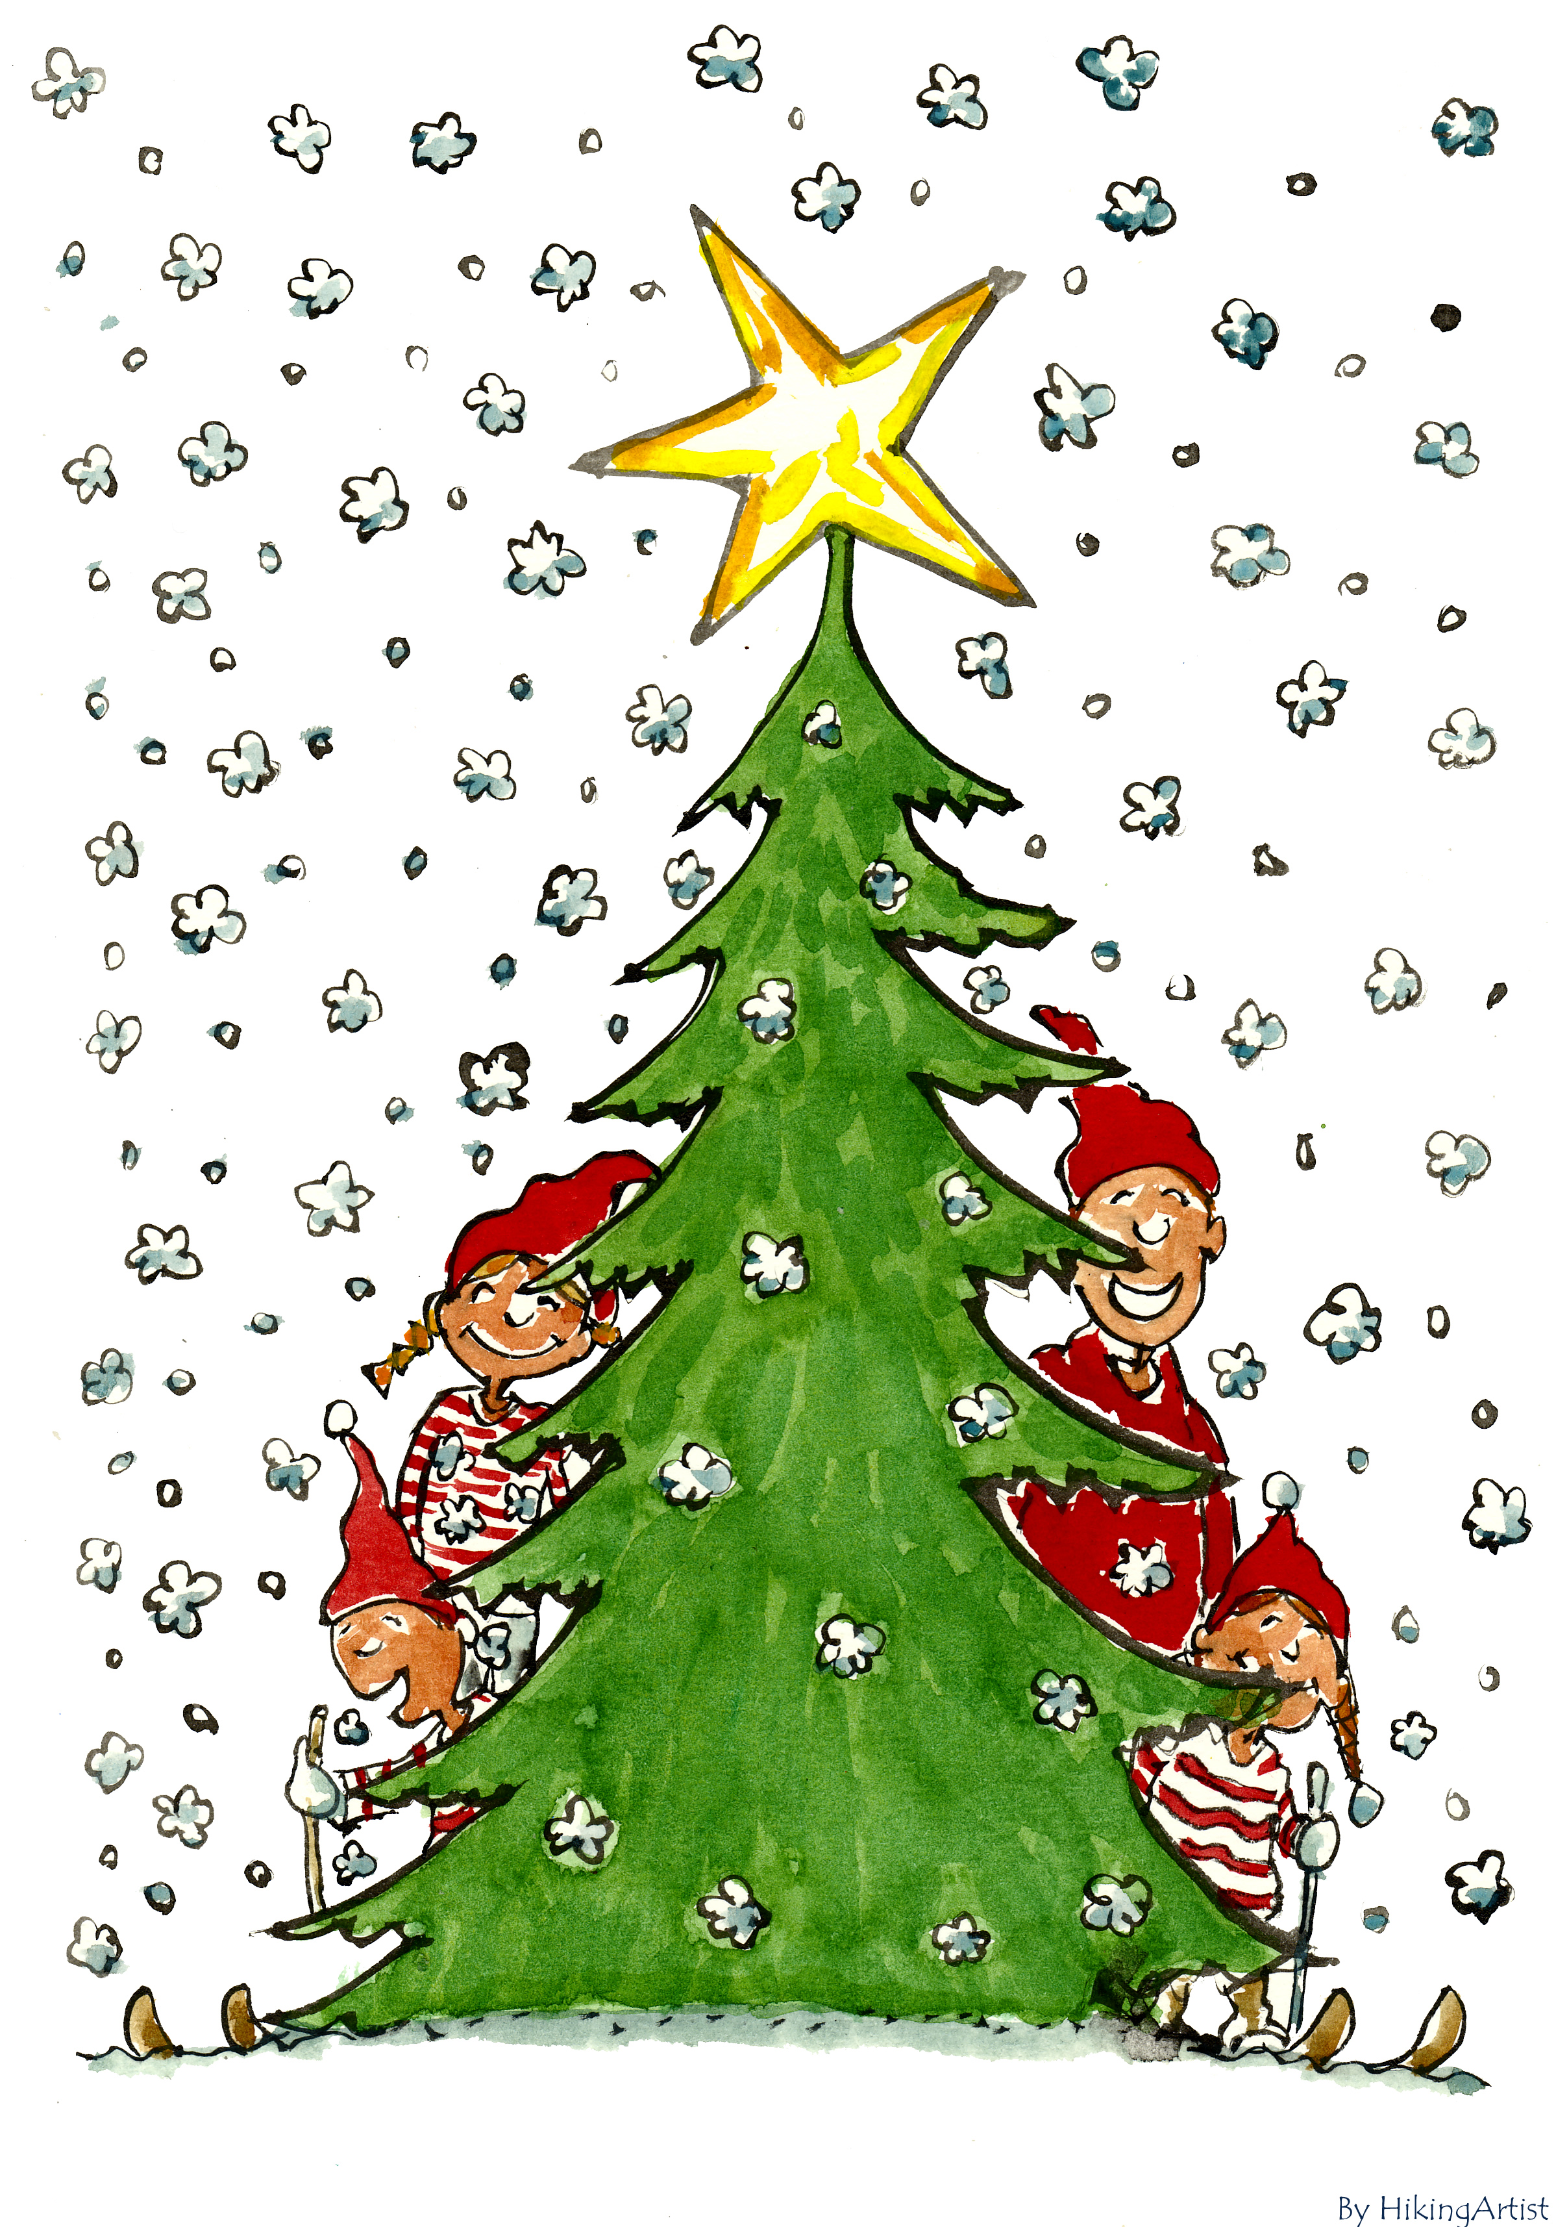 | 25   | 26  Aunt Mimi- Acoustic Guitar Pop hits and Rock Edge
27 | 28 | 29  Stump Trivia | 30  Brittany Hill | 31  John Fitzsimmons & Friends- Traditional Pub Music  
48 Monument Sq, Concord, MA 978-369-2373 www.concordscolonialinn.com

