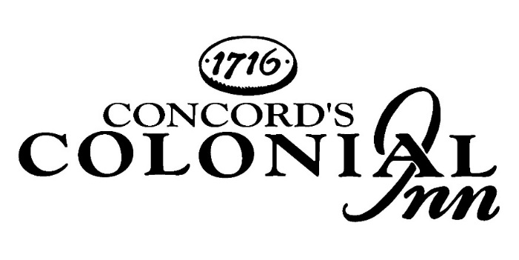

Afternoon Tea

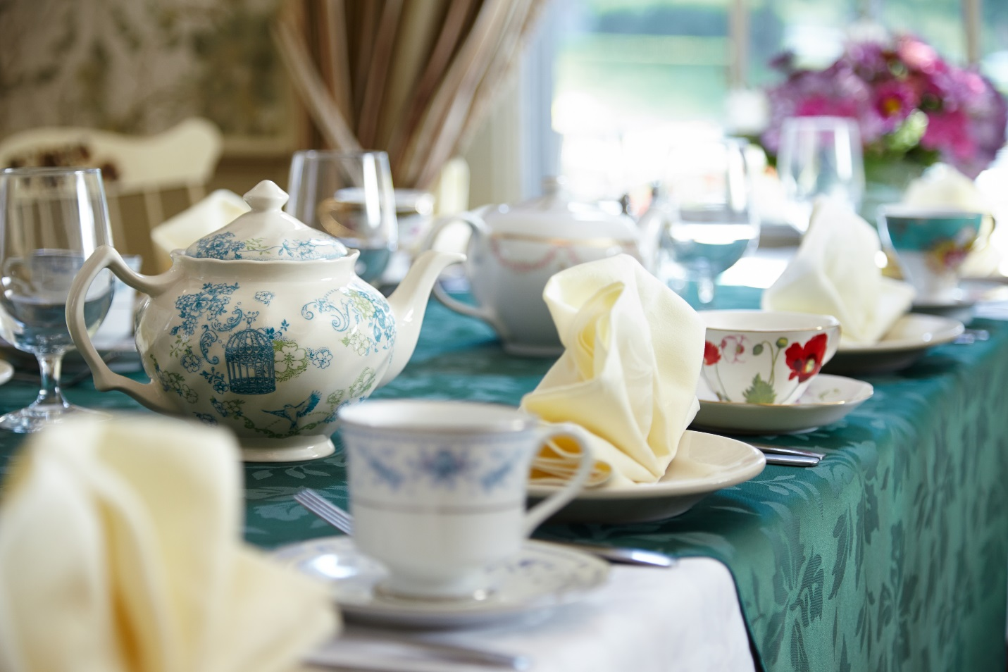

Colonial Inn Afternoon Tea $32.00
Assorted Fine English, Chinese & Indian Teas
Banana Pecan Bread, Citrus Glazed Pound Cake, Lemon Blueberry Scones
Cucumber Sandwiches, Smoked Salmon Canapés, Chicken Salad Croissants, Caprese Sandwiches
English Toffee, Lemon Shortbread, Chocolate Covered Strawberries, Petit Fours, French Macaroon
Devonshire Cream, Raspberry Preserves & Lemon Curd

Children’s Tea Menu $16.00
Beverages
Hot Chocolate, Tea, or Milk
Freshly Baked Blueberry and Lemon Scones
Honey Clotted Cream, Strawberry Preserves, Lemon Curd
Peanut Butter and Jelly Finger Sandwiches, Turkey and Cheese Sandwiches
Brownie & Cookie Assortment

Afternoon Tea Enhancements

Tasty Additions Prices per person
Bruschetta, Tomato, Basil, Parmesan, EVOO, Saba $3.00
Fresh Mozzarella, Tomato, Basil Skewer, EVOO, Balsamic Glaze $3.00
Antipasto Skewers, Artisan Cheese & Cured Italian Meats $3.00
Black Olive Tapenade Crostini, Parmesan Cheese, Basil Oil* $3.00
Asparagus Wrapped with Prosciutto, Sweet Balsamic Drizzled $4.00
Ahi Tuna Wontons, Seaweed Salad, Pickle Ginger, Sesame Soy Sauce $4.00
Shrimp Cocktail, Horseradish Cocktail Sauce, Lemon $4.00
Crab Salad Brioche, Lemon Tarragon Vinaigrette $5.00

Specialty Sandwich Upgrades
Baked Ham & Swiss Cheese Roll Ups with Dijonaisse $2.00
Egg Salad on Croissant $2.00
Turkey, Apple & Brie on Wheat Bread $3.00
Quiche Florentine with Spinach & Tomatoes $3.00
Roast Beef with Cheddar & Horseradish Cream Pinwheels $4.00
Lobster Slider with Lemon Mayonnaise & Fresh Herbs $7.00

Dessert Upgrades
Fresh Fruit Skewers $3.00
Seasonal Fresh Fruit on Skewers with Yogurt Drizzle
Cheesecake Bites $3.00
Assorted Cheesecake Flavors

Beverages

NON-ALCOHOLIC BEVERAGES

Soda $3.00 each
Bottled Water Small 12oz $3.00 each
Large 28oz $6.00 each
Pitcher of Iced Tea or Lemonade $12.00 each
(Serves 6 people)
Coffee, Tea, or Decaffeinated Coffee $4.00 per person

SPECIALTY PUNCHES

Fruit Punch (Non-Alcoholic) $35.00
Hot Mulled Cider (Non-Alcoholic) $35.00
Egg Nog (Non-Alcoholic) $35.00
Rum Spiked Egg Nog $75.00
Mimosa $75.00
Bloody Mary $75.00
Sangria (White or Red) $90.00
Kir Royal $90.00

Punches are priced per gallon and each gallon serves approximately 18-20 glasses

ALCOHOLIC BEVERAGES

House Prosecco $5.00-$6.00
Bottled Beer $5.00-$6.00
Wine (glass) $8.00-$13.00
Cordials $8.00-$12.00
Mixed Drinks $9.00-$11.00
Martinis $11.00-$13.00

